# How to Configure DHCP Server on Cisco Routers

A router connects different networks. A DHCP server provides IP configurations. [Cisco](https://www.computernetworkingnotes.com/ccna-study-guide/how-to-configure-dhcp-server-on-cisco-routers.html) routers support the DHCP service. If you have a [Cisco](https://www.computernetworkingnotes.com/ccna-study-guide/how-to-configure-dhcp-server-on-cisco-routers.html) router, you can use it to configure and run a DHCP server on it.

To explain DHCP configuration steps, I will use Packet Tracer network simulator software. It allows us to configure, test, and verify various configurations on Cisco devices in a simulated environment. No matter whether you use real Cisco devices or network simulator software, the configuration steps are the same.

### **Packet Tracer LAB Setup for the practice of DHCP Server**

Either download the following pre-created LAB or create a packet tracer lab as shown in the following image.

[Pre-created practice lab for the practice of DHCP server](https://www.computernetworkingnotes.org/download/cisco/ccna-study-guide/pklab/csg72-01-configure-dhcp-server-on-cisco-router-lab-without-configuration.pkt)

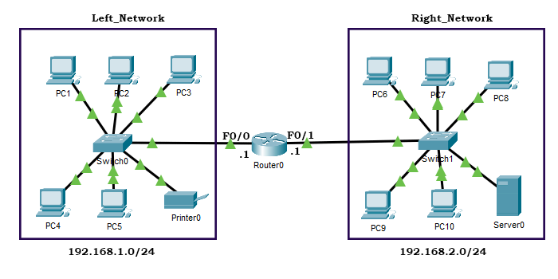

In this lab, there are two networks: **Left_network** and **Right_Network**. Both networks are connected to the router's **Fast Ethernet 0/0** and **0/1** interfaces, respectively. Now our objective is to configure the following IP configuration on both networks.

|  |  |  |
| --- | --- | --- |
| **Configuration** | **Left_Network** | **Right_Network** |
| IP addresses | 192.168.1.0 to 192.168.1.255 | 192.168.2.0 to 192.168.2.255 |
| Available IP addresses for hosts | 192168.1.10 to 192.168.1.254 | 192.168.2.10 to 192.168.2.254 |
| Subnet mask | 255.255.255.0 | 255.255.255.0 |
| Default Gateway | 192.168.1.1 | 192.168.2.1 |
| DNS Server | 192.168.1.2 | 192.168.2.2 |
| TFTP Server | 192.168.1.3 | 192.168.2.3 |
| Reserved | 192.168.1.4 to 192.168.1.10 | 192.168.2.4 to 192.168.2.10 |

### **Configuring IP configuration on the router**

A router connects different networks. If a router is connected to a network, hosts of the network use the router as the default gateway to reach the host of other networks.

In our example, since the **Left_Network** and **Right_Network** are respectively connected to the **Fast Ethernet 0/0** and **0/1** interfaces of the router, both networks will use the IP addresses of their respective interfaces as the default gateway IPs.

In simple terms, **Fast Ethernet 0/0** and **Fast Ethernet 0/1** of the router are the default gateways of the **Left_Network** and **Right_Network** respectively. Before configuring the router to act as a DHCP server, we have to configure and enable these interfaces.

To configure and enable these interfaces, access the command prompt of the router, and execute the following commands.

Router>enable

Router# configure terminal

Router(config)# interface FastEthernet 0/0

Router(config-if)# ip address 192.168.1.1 255.255.255.0

Router(config-if)# no shutdown

Router(config-if)#exit

Router(config)# interface FastEthernet 0/1

Router(config-if)# ip address 192.168.2.1 255.255.255.0

Router(config-if)# no shutdown

Router(config-if)#exit

The following image shows the above commands on the packet tracer.

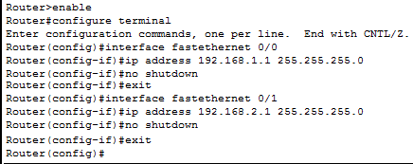

This tutorial is the sixth part of the article **'DHCP (Dynamic Host Configuration Protocol) basic concepts, configurations, functions, and options Explained'.** Other parts of this tutorial are the following.

### **Configuring DHCP server on the router**

For each network that will obtain IP configuration from the DHCP server, we have to create and configure a DHCP pool on the router. In our example, we have two networks, so we have to create two DHCP pools, one for each network.

Use the following commands to create and configure a DHCP pool for the **Left_Network**.

Router>enable

Router#configure terminal

Enter configuration commands, one per line. End with CNTL/Z.

Router(config)#ip dhcp excluded-address 192.168.1.0 192.168.1.10

Router(config)#ip dhcp pool Left_Network

Router(dhcp-config)#default-router 192.168.1.1

Router(dhcp-config)#dns-server 192.168.1.2

Router(dhcp-config)#option 150 ip 192.168.1.3

Router(dhcp-config)#network 192.168.1.0 255.255.255.0

Router(dhcp-config)#exit

The following table describes the above commands.

|  |  |
| --- | --- |
| **Command** | **Description** |
| ip dhcp excluded-address 192.168.1.0 192.168.1.10 | This command tells the DHCP server not to assign the addresses from **192.168.1.0** to **192.168.1.10** to DHCP clients. |
| ip dhcp pool Left_Network | This command creates a DHCP pool named, **Left_Network** and changes command mode to DHCP pool configuration mode. |
| default-router 192.168.1.1 | This command assigns the default gateway to clients of this DHCP pool. |
| dns-server 192.168.1.2 | This command sets a primary DNS server for the clients. |
| option 150 ip 192.168.1.3 | This command provides the IP address of the TFTP server to the clients. |
| network 192.168.1.0 255.255.255.0 | This command specifies the range of IP addresses for the pool. |
| exit | This command exits DHCP pool configuration mode. |

Create and configure a DHCP pool for the **Right_Network** using the same commands as shown below.

Router(config)#ip dhcp excluded-address 192.168.2.0 192.168.2.10

Router(config)#ip dhcp pool Right_Network

Router(dhcp-config)#default-router 192.168.2.1

Router(dhcp-config)#dns-server 192.168.2.2

Router(dhcp-config)#option 150 ip 192.168.2.3

Router(dhcp-config)#network 192.168.2.0 255.255.255.0

Router(dhcp-config)#exit

Router(config)#

The following image shows how to execute the above commands on the router.

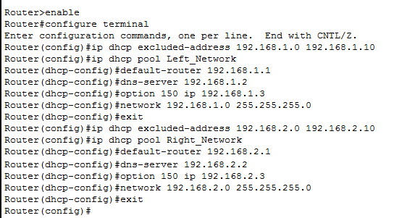

### **Configuring DHCP clients**

To configure a device as a DHCP client, change its IP configuration option to **DHCP**. To do this, click the device. In opened Windows, click the **IP configuration option** from the **Desktop** menu and set the **IP configuration option** to **DHCP**.

The following image shows the above procedure.

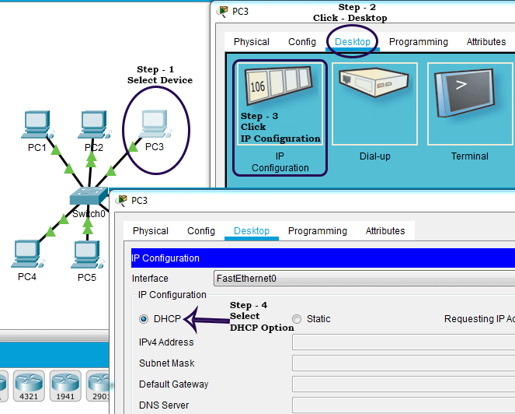

### **Verifying DHCP clients**

To verify that the client has obtained IP configuration from the DHCP server, you can check the IP configuration option of the client again. For example, the following image shows how to verify this on a host of the **Left_Network**.

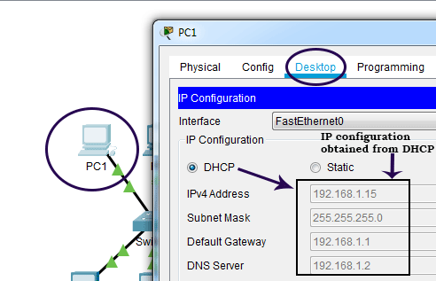

The following image shows how to verify this on a host of the **Right_Network**.

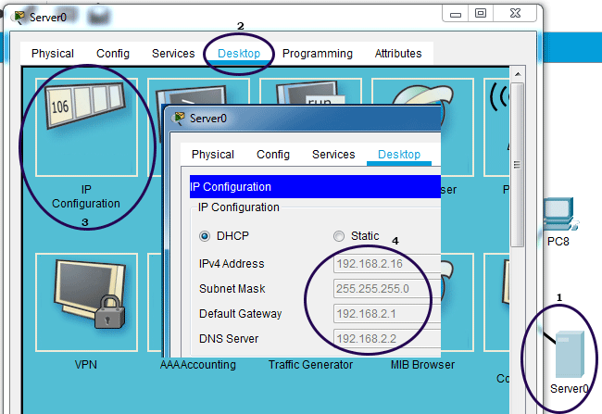

### **Verifying the DHCP Server**

To verify that the DHCP server is working properly and to see the IP addresses that are provided by the DHCP server, run the following command in**privileged-exec mode**.

#ip dhcp binding

The following image shows the output of this command.

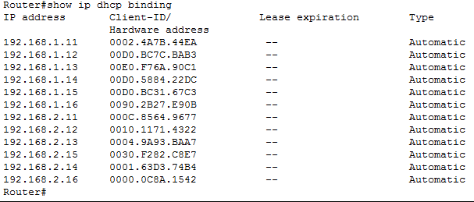

To view detailed information about a specific DHCP pool, use the following command.

#show ip dhcp pool [pool-name]

For example, the following commands list the detailed information about the DHCP pools: **Left_Network** and **Right_Network**, respectively.

#show ip dhcp pool Left_Network

#show ip dhcp pool Right_Network

The following image shows the output of the above commands.

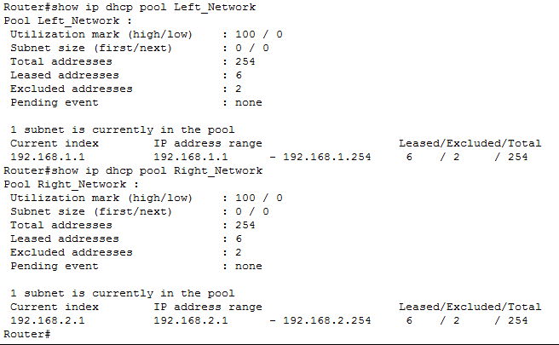

#### Configured LAB of the example